Data Scraping and Analysis Report

Introduction
This project focuses on extracting employee information from a web page, processing the data, and performing Python analysis. The extracted data includes employee names, job titles, departments, and email addresses. The data is then stored in a CSV file and analysed using Pandas and Matplotlib to generate visual insights.

Technologies and Libraries Used
- requests - To fetch HTML content from the web.
- BeautifulSoup (bs4) - To parse and extract data from HTML.
- csv - To store extracted data in a structured CSV format.
- pandas - To process, analyse, and manipulate tabular data.
- matplotlib - To create visual representations of the data.

Project Workflow
1. Web Scraping
To fetch the employee data from the webpage, I used the requests module to send an HTTP request and retrieve the HTML content:
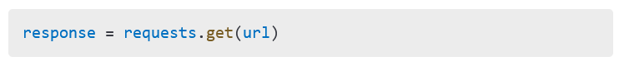
Next, I used BeautifulSoup to parse the HTML content and locate the relevant table containing employee details:
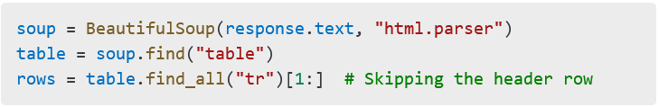
Each row of the table was extracted and processed to get individual employee details.

2. Storing Data in CSV
After extracting the data, I stored it in a CSV file using Python’s csv module:
This structured format ensures easy access and further processing of the data.

3. Data Analysis and Insights
Using pandas, I performed analysis on the scraped employee data:
- Count of Employees per Department
b. Count of Employees per Job Title
These counts helped me understand the distribution of employees across departments and job roles.

Visual Representations
To display both graphs on a single page, I created a combined visualisation using Matplotlib:

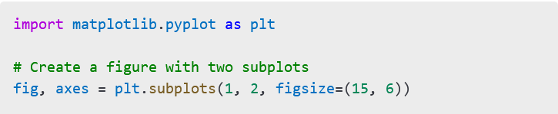
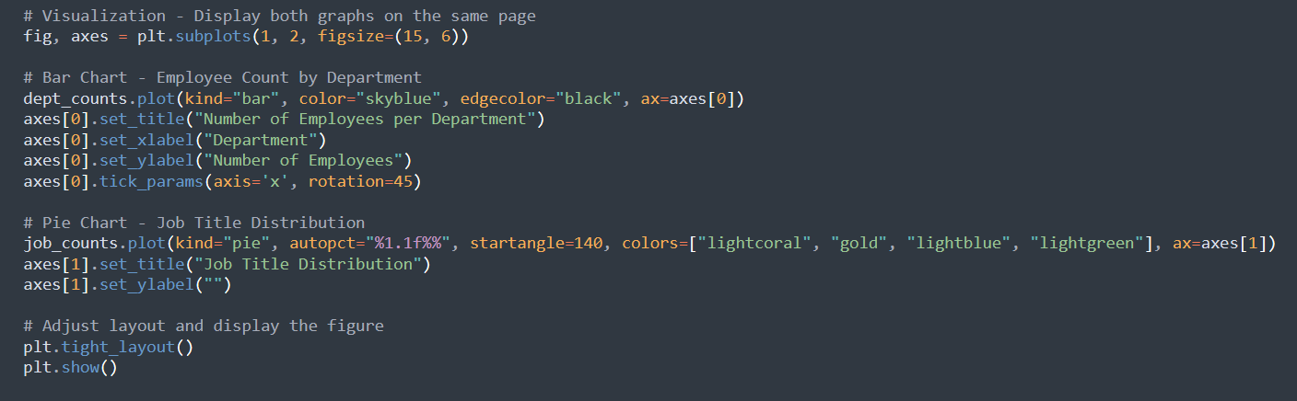

Graphs:

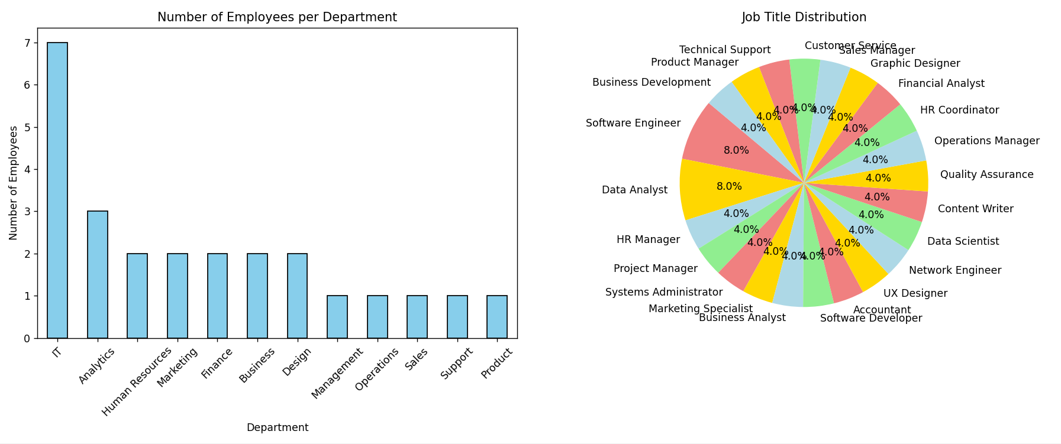

Conclusion
This project demonstrates the effectiveness of web scraping for data collection, followed by data analysis and visualisation. I successfully extracted employee details, structured the data in a CSV file, and used Python libraries to analyse and visualise insights about employee distribution.

